# Problem



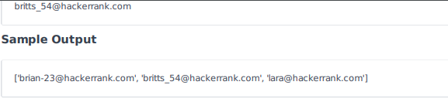

# Josh Solution

import re

regex = r'\b[A-Za-z0-9._%+-]+@[A-Za-z0-9.-]+\.[A-Z|a-z]{2,}\b'

def fun(s):

    # return True if s is a valid email, else return False

    if(re.fullmatch(regex, s)):

        print("True")

    else:

        print("False")

n = int(input())

#print(n)

email_list = []

for _ in range(n):

    x = input()

    #print(x)

    if re.match(regex, x):

        email_list.append(x)

        #print(email_list)

#print(email_list)

sorted_email_list = sorted(email_list)

print(sorted_email_list)

# Other Solution

import re

def fun(s):

pattern = re.compile("^[\\w-]+@[0-9a-zA-Z]+\\.[a-z]{1,3}$")

return pattern.match(s)

# Other Solution 2

import re

def fun(s):

  pattern = re.compile("^[A-Za-z0-9._%+-]+@[A-Za-z0-9.-]+\.[A-Z|a-z]{2,}$")

  return pattern.match(s)

def filter_mail(emails):

    return list(filter(fun, emails))

if __name__ == '__main__':

    n = int(input())

    emails = []

    for _ in range(n):

        emails.append(input())

filtered_emails = filter_mail(emails)

filtered_emails.sort()

print(filtered_emails)